www.copperhead.co
112 Elizabeth Street
Suite 101
Toronto, Ontario, Canada
M5G 1P5

BACKING UP DATA ON A COPPERHEADOS PHONE

Copperhead Support Team

support@copperhead.co

OVERVIEW

Here you will find instructions for Copperhead customers on backing up data on their CopperheadOS phone to a thumb drive or NextCloud instance. Customers may need to re-flash or factory reset their phone from time-to-time and these actions will wipe all user data from the phone. This document is written with an assumption of basic technical aptitude: customers reviewing this document should understand how to connect their CopperheadOS phones to their respective platform (i.e., Windows, Linux). This document is presented in 3 formats: odt (Open Document Text), docx (Microsoft XML) and PDF. The included PDF does not come with animated graphics and should be referenced against the gifs provided with the document.
To ensure the safety of data on CopperheadOS phones, CopperheadOS phones should be always kept in a minimal data state. Contacts, photos, messages and other data should be backed up to an encrypted storage container – using sync adapters such as NextCloud and DavDroid.

Seedvault

Seedvault is the primary backup tool available to CopperheadOS users. Seedvault creates encrypted system backups, protected by a seed key.
Seed Key: A twelve-word key used to encrypt and access Seedvault backups. Write this key down, as it will be needed to create and restore your backup. If you are a third-party managing a phone for a client and they have created Seedvault backups, you will either need their seed key, or they will need to restore these backups themselves. New seed keys can be checked and re-generated by Seedvault in Settings -> System -> Advanced -> Backup -> Recovery code. Newly generated recovery codes / seed keys will only work with new backups.
After writing down your key, you will be asked to select a backup location. This can be in the phone’s internal storage, a thumb drive, or on a remote NextCloud server through the NextCloud App*.
If you are using the phone’s internal storage, you will need to retrieve the “.SeedvaultBackup” folder while copying other user data to a host drive for storage when resetting or re-flashing a phone. The period preceding the folder name designates the folder as “Hidden” in Linux and Android file systems.
* Please note that to use your NextCloud provider as a backup location, you will need to have already configured the NextCloud app and turned off the in-app passcode to enable automatic remote backups.

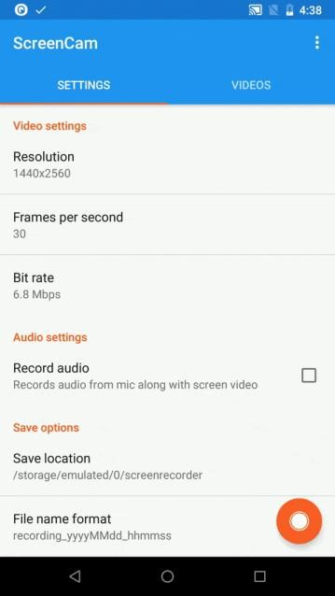
Connecting a CopperheadOS phone to a drive
Note that the various OS’s (Windows, Mac, Linux, BSD etc.) will have different interfaces for connecting to a drive and we could not cover them all here.

Connect USB to phone → Pull down navigation drawer → Android System (USB Charging this phone) → Transfer files

CONTACTS
Exporting contacts is as easy as accessing the Contacts application and exporting from the settings menu.

Contacts → Settings → Export → Export to vcf → Find on file system

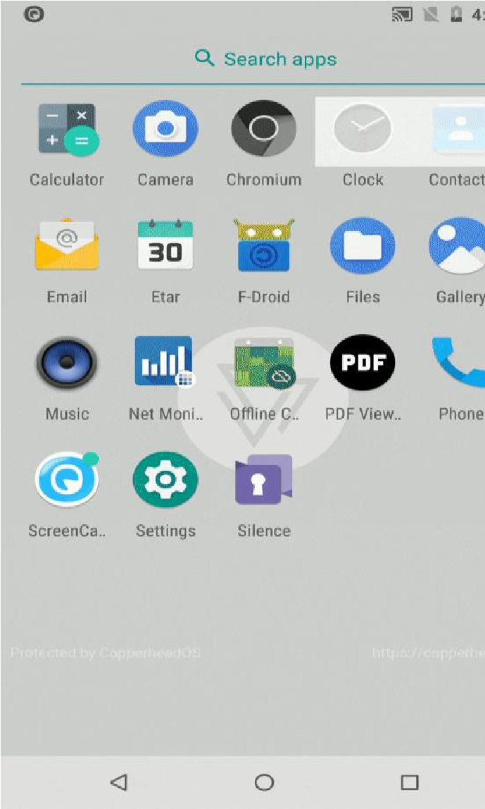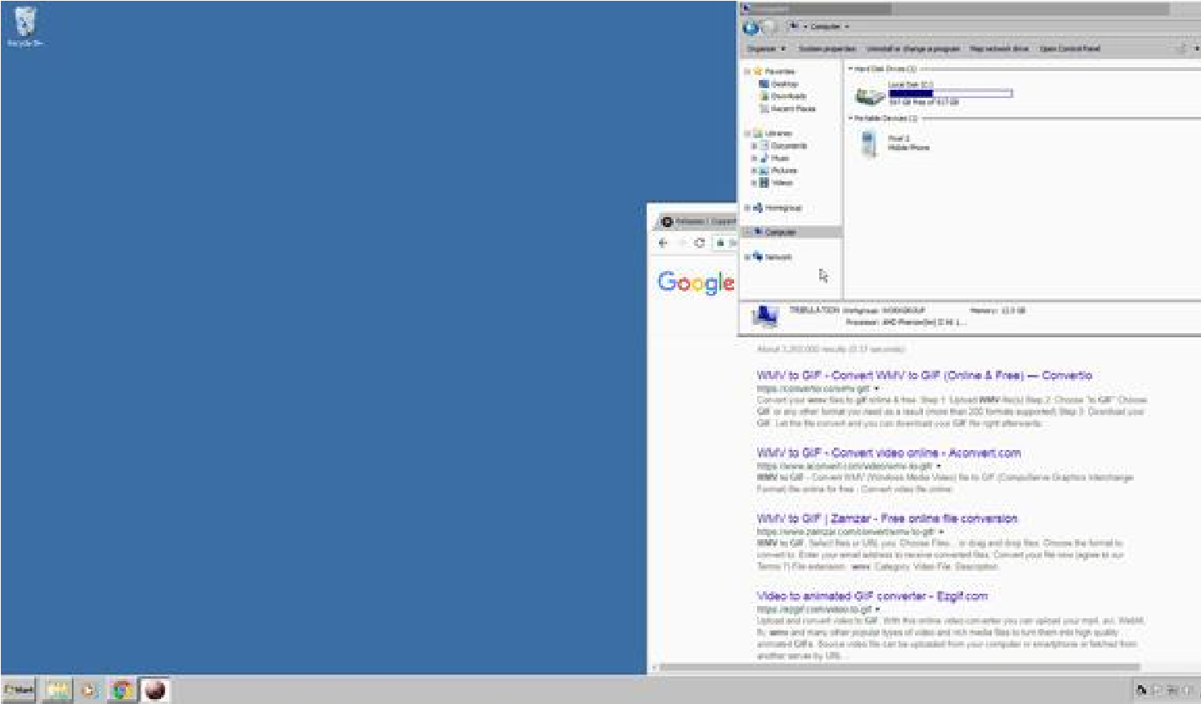

Illustration 1: Exporting Contacts

PHOTOS

The various camera applications available for CopperheadOS will often store images (unencrypted) to shared storage (DCIM/Camera) section of the phone. They should be backed up using manual phone connection means. The displayed method does not show camera applications that correctly encrypt their information – please reference their documentation on how to back things up.

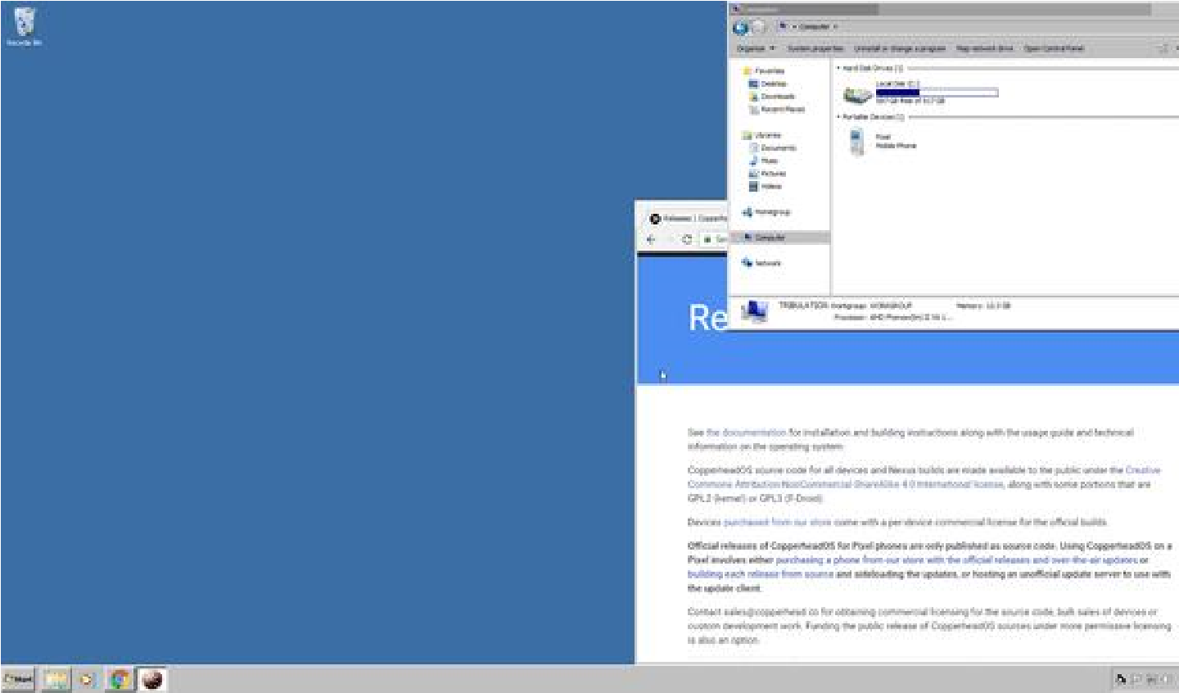

- Find phone on system:
◦ Internal shared storage
◦ DCIM/Camera/OpenCamera/etc.
- Copy all files to drive

Signal

Signal has an internal Chats backup feature. To turn it on, open Signal and tap the hamburger menu to open Settings -> Chats -> Chat backups (at the bottom of the menu). After creating the backup, you can then copy the folder from internal storage to a thumb drive, host computer, or upload it to your NextCloud instance.

OTHER CONSIDERATIONS

There are other types of sensitive data that may need to be backed up before flashing a CopperheadOS phone which include Chat/Messaging apps (WhatsApp, Threema, SilentPhone), SSH keys, 2FA codes or Cryptocurrency wallets or keys. Please refer to each application’s respective documentation when looking to flash your phone.
If you have any other questions or concerns do not hesitate to contact Copperhead support. We look forward to supporting you today and in the future!

